**Google’s AI powered Predictions Technology**

AI used in google maps has practically changed the world. The mapping of the road has become 10 times faster than what it was five years ago. Every place in the world can be seen by us virtually.



***Advantages of using AI in Google Maps***

1. **Teaching maps to identify and forecast when to apply brakes**
2. **Using AI to go beyond driving**

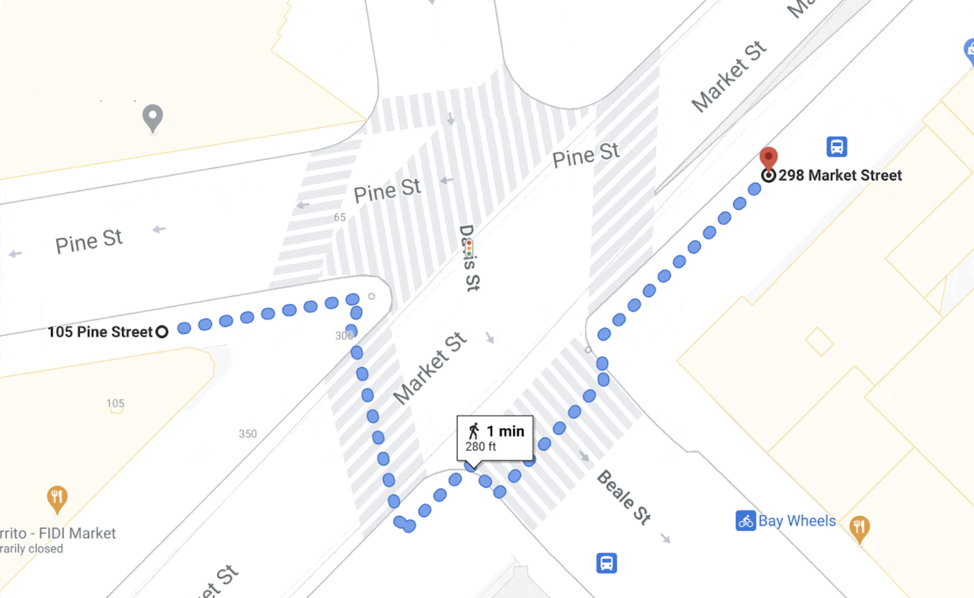

1. **Single-feature AI model that classifies Buildings**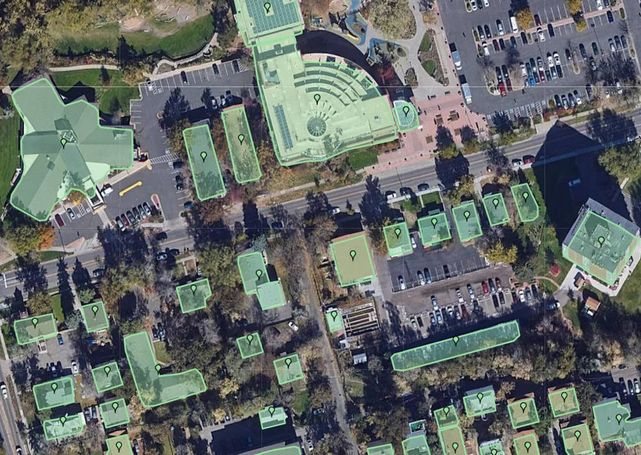
2. **Full-scene AI models that capture Multiple Categories of objects at once.**

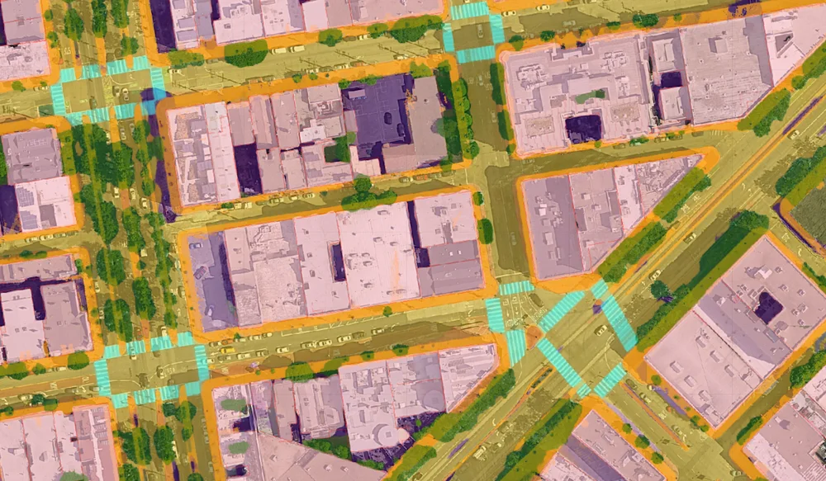

1. **Road information that reflects the Real World**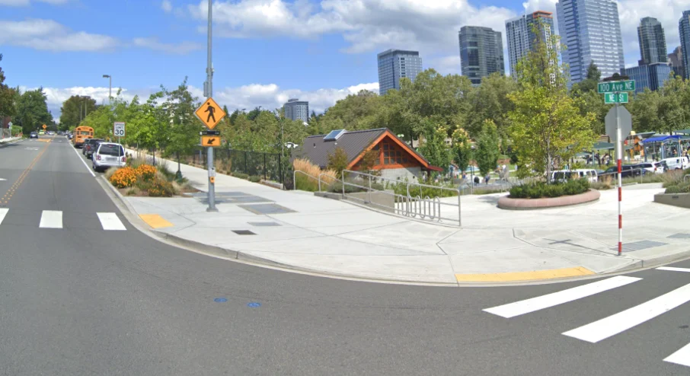

**Source:** [**https://blog.google/products/maps/google-maps-101-ai-power-new-features-io-2021/**](https://blog.google/products/maps/google-maps-101-ai-power-new-features-io-2021/)

[**https://blog.google/products/maps/how-ai-and-imagery-build-self-updating-map/**](https://blog.google/products/maps/how-ai-and-imagery-build-self-updating-map/)